VFW FOUNDATION’S HOME DEPOT FOUNDATION COMMUNITY IMPACT GRANT COMPLETION GUIDE 2019-2020
Please read through all information on this guide before beginning the application so you will become acquainted the general rules and process. Do not worry that your Post is not a registered 501(c)(3) nonprofit organization. You can still apply as a 501(19), nonprofit, veterans group.
You may access the application using the link found toward the bottom of this page.
Once you have begun the application try to complete it in one session without saving. We have received multiple reports that using the “Save and Finish Later” option has led to a loss of work and applicants had to reenter parts of the application.
It is strongly recommend that you copy your answers to a separate document after completing the essay style questions.
PLEASE NOTE: There is a new requirement in applying for the Home Depot Community Impact grant this year. Applicants must provide a project budget via a Microsoft Excel File. Details and an example on how to do this can be found on pages 13-19 of this document. You will submit the Project Budget on the same page of the application that you upload your IRS determination letter/990.
If you have any questions about this application or guide, please contact Grants Coordinator Jason Couch at jcouch@vfw.org or at 816-968-1174.
TO APPLY FOR A HOME DEPOT COMMUNITY IMPACT GRANT, BEGIN BY GOING TO THE FOLLOWING WEBSITE:
https://corporate.homedepot.com/grants/community-impact-grants
Once the page has loaded, scroll to the bottom and click the “NONPROFIT APPLICACTION” button as indicated below.
After you have clicked “NONPROFIT APPLICATION,” you will arrive at the screen seen on the next page of this guide.
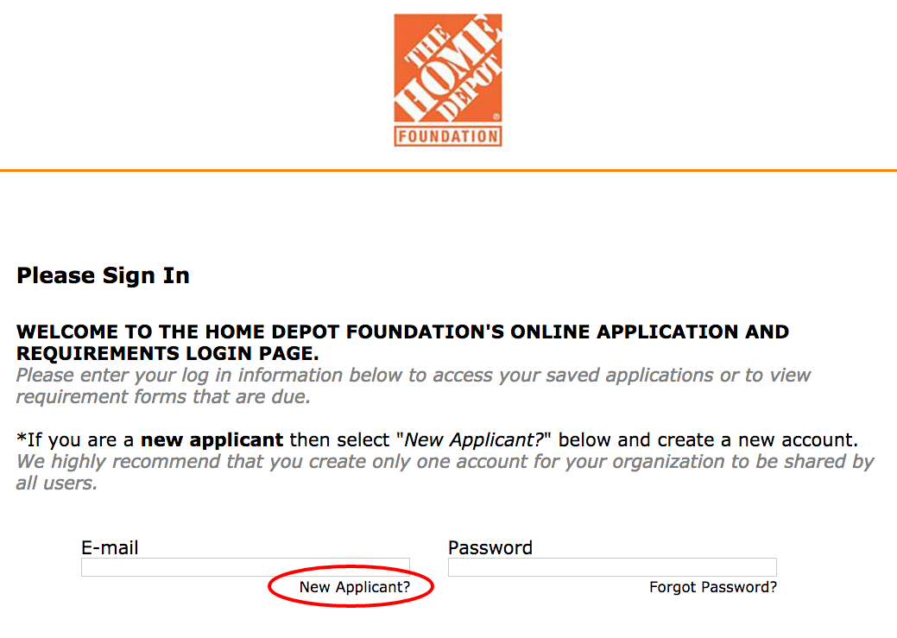
Click the “New Applicant?” button circled in red above.
After clicking “New Applicant?” You will be brought to the screen seen below. Enter an email address you frequently use, create a password with at least five characters and click “Continue.”
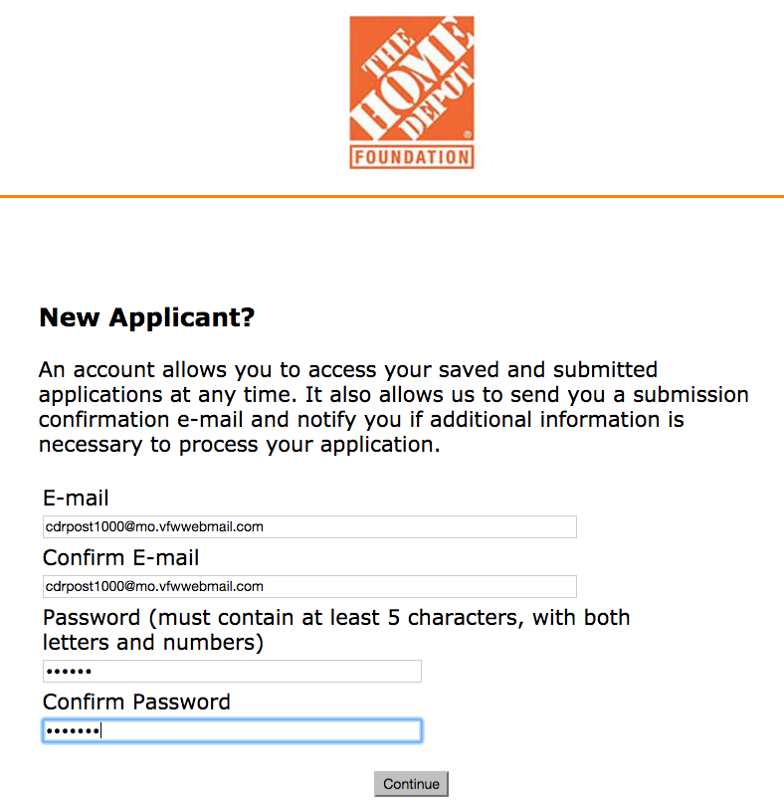

Now that you have successfully established a username and password, you will be brought to the TAX ID Instructions page. You now must enter a valid Tax ID Number to continue. This is also referred to as an EIN, or Employee Identification Number. Again, this does NOT need to be a 501(c)(3) tax ID number, it should be your Post’s Tax ID Number.

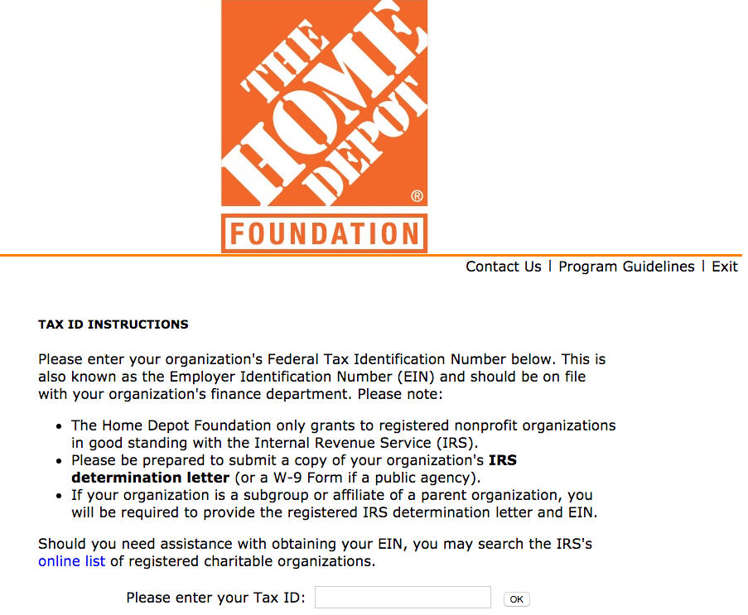

After you have entered your EIN and clicked “OK” you will be brought to Part 1 of the application. This part is depicted on the next page of this document. It is a series of eleven questions which must be answered exactly as show in order to proceed to Part 2.

ANSWER ALL OF THE QUESTIONS AS SHOW BELOW OR YOU WILL NOT BE ABLE TO PROCEED.
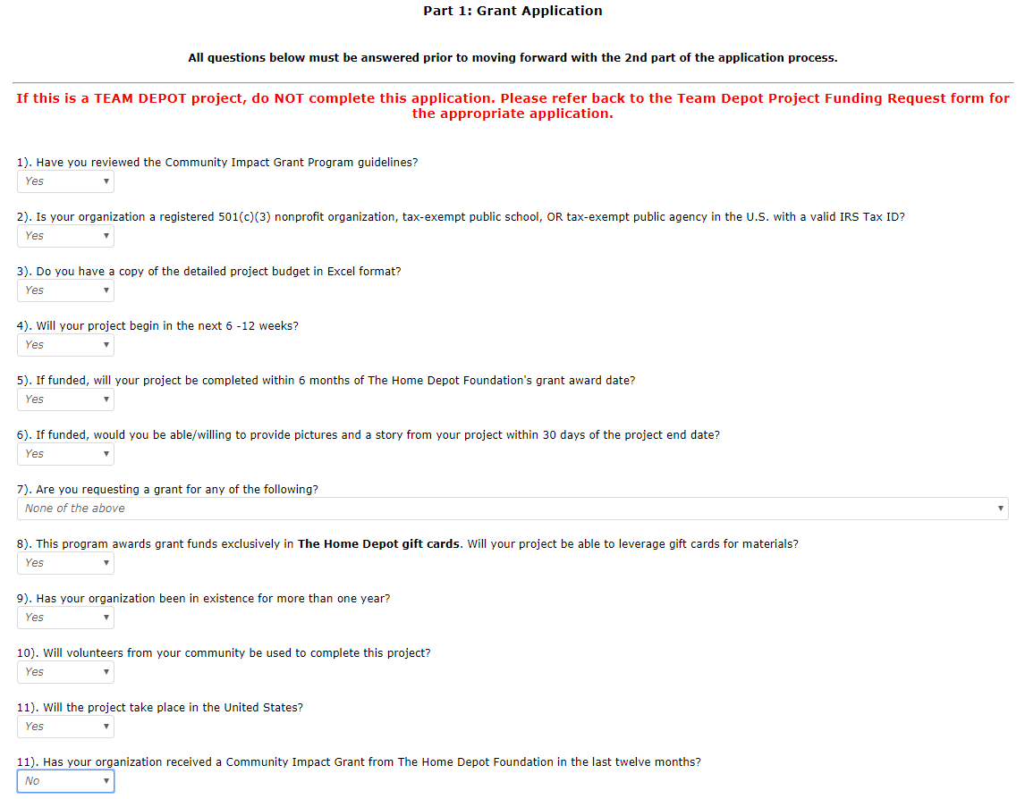
You should answer “Yes” to every question except question 7, which should be answered as “None of the above,” and the final question, question 11, which should be answered “No.”
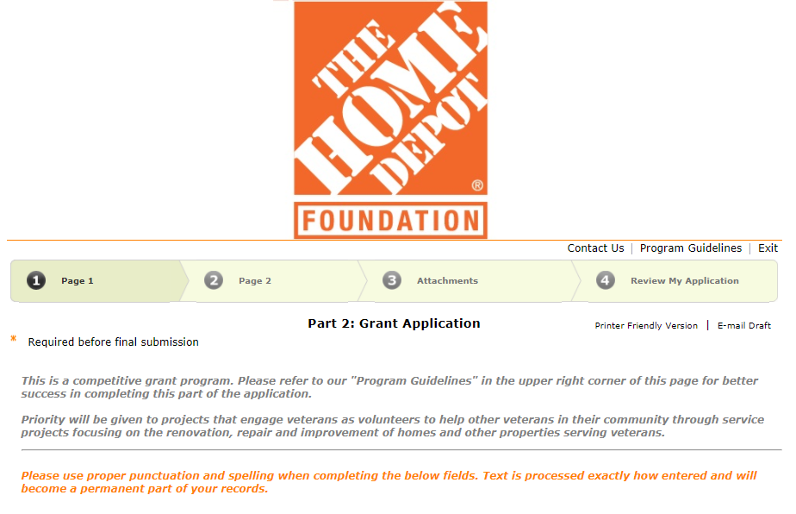
If you entered the answers correctly you will be brought to Part 2 of the application. The header for the page looks like this:
Page 1 of Part 2 is made up of five sections:
ORGANIZATION INFORMATION --This section is made up of questions requesting basic information about your Post such as contact and mission details.
ORGANIZATION PRIMARY CONTACT I & II -- The Post member charged with completing the application will input contact information here.
STATEMENT OF ISSUE & SOLUTION I & II -- Here you will provide details about your project. Home Depot wants to know what you are asking money for, why it is important and how long it will take to complete among other questions.
PROJECT FINANCIALS -- This is where you will provide information about the project’s cost.
VETERAN INFORMATION -- Home Depot wants information about the number of and type of veterans you assists (i.e., Homeless, Disabled, Transitioning).
STORE INFORMATION -- This section concerns which Home Depot store you would use your gift cards at.
Scroll down to ORGANIZATION INFORMATION and answer the questions about your Post as shown in the example on the next page of this document.
ORGANIZATION INFORMATION
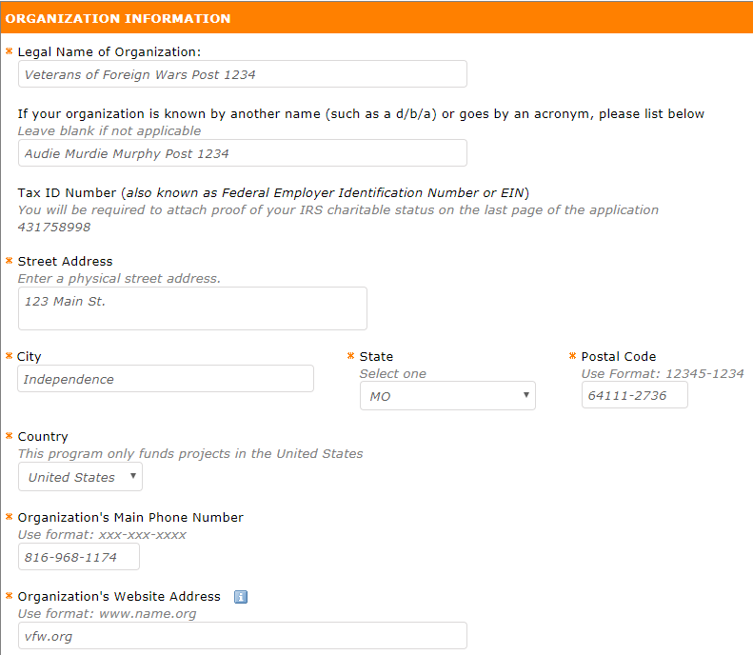

In this section provide the basic contact information for your Post. Note how the “Legal Name of Organization” field is completed in this example. Always write your Post’s name here as displayed in the example or how it is shown on your annual tax statement. The second question is where you might write “VFW Smith-Parker Post 99999.”
Be sure to select a state abbreviation code via the dropdown box and use your Post’s nine-digit zip code as shown above. Using your Post’s own website is preferable, but if your Post does not have a website use www.vfw.org.

The remaining questions are in regard to your Post’s purpose. The first of these questions is “Please select the organization type that best describes your organization.” Make sure to select “Veterans Organization.”
The next question asks for your Post’s mission statement. If your Post does not have a unique mission statement then use VFW National’s: “Our Mission: To foster camaraderie among United States veterans of overseas conflicts. To serve our veterans, the military and our communities. To advocate on behalf of all veterans.” Be mindful of the 100 word limit.

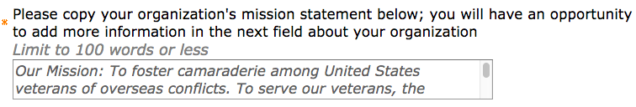
The next section requests a summary of programs and services your Post provides. A sample narrative is provided below to give you some ideas about what to write here. Note the 100 word limit.
Our organization offers several services to veterans, youth and our community. Please see the list below of just a few of the many programs/services we provide.
-Regularly provide cash grants to needy local veterans from our relief fund program.
-Annually provide scholarships to k-12 students.
-Hold fundraisers and clothing and food drives for needy area residents.
-Recognize under-appreciated heroes such as police officers and teachers in our community with awards and events.
-Lend our space free-of-charge to other nonprofit groups. We provide funeral honors for our area's fallen veterans.
-We hold POW and Memorial remembrance events, patriotic celebrations on 4th of July, Flag Day, Veterans Day and more.
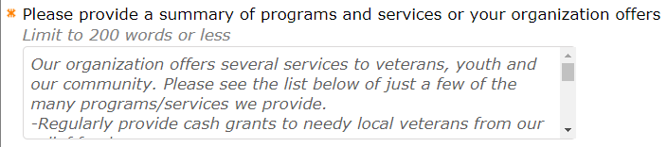

Once you have completed the programs and services question, you will need to provide your annual budget. It is advisable to check with your Quartermaster and/or accountant to find the correct figure. Note the annotation under the question, “Please do not add text symbols, only numbers.” You will need an exact dollar and cent figure, such as “50,000” and “00” in each respective box. Do not try and use a rage such as, 50-2000,” it will not work. There is a 200 word limit to this field.
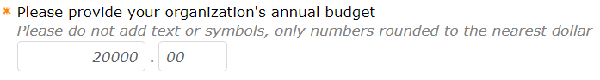
Two the right and below the annual budget question are three questions (indicated by the blue boxes below) about your organizations’ primary contact. This questions should be answered with information about whomever has been charged with completing this application and is responsible for the project’s completion.
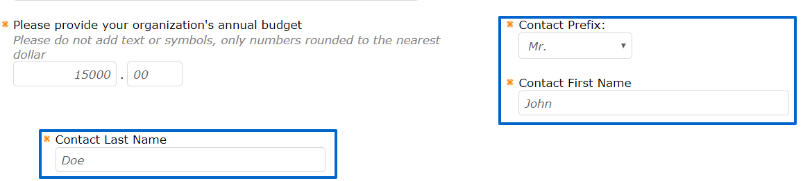
ORGANIZATION PRIMARY CONTACT I
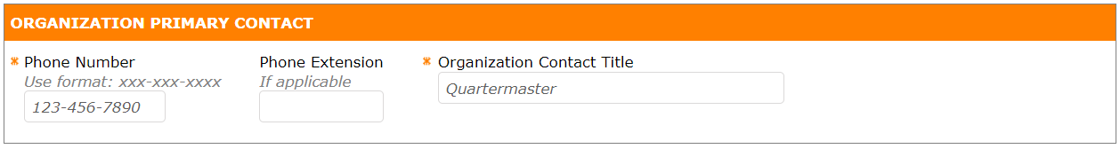
There are two nonconsecutive sections titled Organization Primary Contact. For the first question, you will need to provide the contact’s phone number and title. For all questions about the primary contact, use information that will allow Home Depot to easily reach you. Failing to do so could result in your Post not obtaining this grant.

STATEMENT OF ISSUE & SOLUTION I
Following the contact information sections, you will find the first STATEMENT OF ISSUE & SOLUTION section. As with the Organization Primary Contact sections, there are also two nonconsecutive sections for STATEMENT OF ISSUE & SOLUTION. This is where you will answer questions regarding what your Post needs funding for and how the project will be executed. The first question is about your project’s title.
Note that it should be fewer than fifteen words. Along with Home Depot’s provided examples, some others might be, “Meeting Hall Painting,” “Ladies Restroom Repair Initiative,” etc.
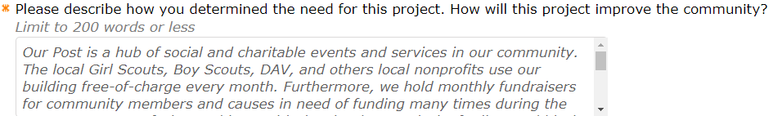
The need for your project is the next thing asked about. Pay special attention to “How will this project improve the community?” This is where you want to explain how having a presentable and functional Post building benefits the community. Below is the example language you can model your entry after. This field has a 200 word limit.
“Our Post is a hub of social and charitable events in our community. The Girl Scouts, Boy Scouts, DAV, and others local nonprofits use our building free-of-charge every month. Furthermore, we hold monthly fundraisers for community members and causes in need of funding many times during the year. We are now facing problems with the city due to a lack of toilets and black mold in our facility. Getting our restrooms repaired is of the utmost importance to keeping our Post open. If these repairs are not made we could potentially lose our business license with the city. Without our building as a meeting place for so many charitable groups and causes in our area, a drastic number of unmet needs in our community may never be addressed. With Home Depot's support in making these needed repairs, our town will continue to aid the less fortunate and make this a truly great place to call home.”

ORGANIZATION PRIMARY CONTACT II
You will now need to provide an email address for the primary contact. Be sure to use an email address you frequently check.
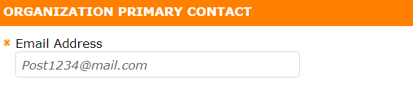
STATEMENT OF ISSUE & SOLUTION II
For the second part of the STATEMENT OF ISSUE & SOLUTION section, you will describe what needs to be fixed and what materials you will need to make your repairs. Please see the next page for an example narrative.

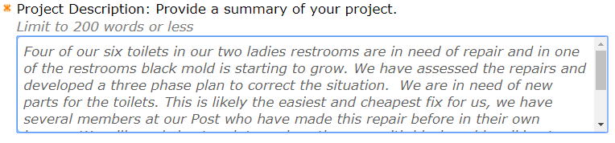
“Four of our six toilets in our two ladies restrooms need repaired and in one of the restrooms black mold is starting to grow. We are in need of new parts for the toilets. This is likely the most efficient repair for us, because we have several members at our Post who have made this repair before in their own homes. One of our members is a drywall professional who told us what we would need to make the repairs. An itemized list of materials he recommended can be found on the project budget. We will need sheet rock, paint, etc. to repair the part of the wall affected with black mold among other materials. We will also need calking to reseal the windows and cut down on the moisture causing the mold. We believe our old central air system is partly to blame, it sits on the roof directly above the restroom in question and the rest of the building has been unaffected. To ensure the problem is abated after we make all of our repairs, we would like to purchase a dehumidifier for the same purpose.”
Simply state what your project is and provide details on how you plan to address it. Once again, keep the 200 word limit in mind.
The next section asks you to list three to five goals about your project.
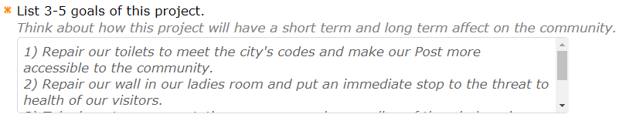
Pay special attention to the sentence under the heading, “Think about how this project will have a short term and long term affect on the community.” This is telling you not to write something like “1. Get a ramp built, 2. Have a ramp for the Post, 3. Get more patrons and members.” What you are looking to do here is use the word “community” a couple of times. Please see the example below for an idea on how to answer this.
“1) Repair our toilets to meet the city's codes and make our Post more accessible to the community.
2) Repair our wall in our ladies room and eliminate the health threat to our visitors.
3) Take long-term preventative measures such as sealing of the windows in order to create a safe, welcoming and accessible environment the whole community will benefit from for years to come.”
The next question is about how you will measure your project’s success upon completion.
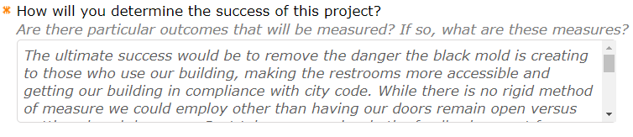
If you are building a disabled-accessibility ramp, clearly constructing the ramp and making it easier for the wheelchair bound and others to get in and out of the Post would make it a success. Correcting whatever deficiency the building had before would make for a successful project. While this is indeed the case, keep in mind that you are selling the idea of your Post to Home Depot. A good number of applicants will get turned down for not elaborating enough when completing sections like these. Under the question Home Depot asks, “Are there particular outcomes that will be measured? If so, what are these measures?” If you can, be sure to address this. It can be difficult to determine what to say here. If you can’t think of any measures you would implement use visitor feedback as your measure as demonstrated below.
“The ultimate success would be to remove the danger the black mold is creating to our Post, making the restrooms more accessible and getting our building in compliance with city code. While there is no rigid method of measurement other than keeping our doors open, our Post takes very seriously the feedback we get from our many visitors. We are met with frequent complaints about the lack of working toilets and black mold. Our aim is to provide the best and healthiest environment possible for our members and visitors. We expect that once these problems are addressed we will receive significant positive feedback. We are hoping to measure the success of the project based on the comments we receive on social media and in inter-personal interactions. We would be more than happy to share any positive feedback about the repairs we receive through Facebook with the Home Depot team!”
Select “Community Building-Community Center” as the answer for this question.
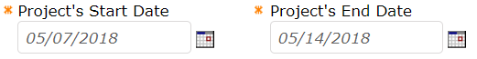
You can enter the date manually or use the dropdown calendars. Be sure to place the date of your project at least six weeks from the date you submit your request, but no more than eighty days from that date. This is in keeping with the answer you gave on the initial questionnaire, but also gives Home Depot time to evaluate your request. Please be aware that the time they take to make a decision could exceed your start date. We strongly recommend that you exercise patience. If you have not heard anything 90 days after submitting, please contact our staff using the information below. We will not be able to remedy the problem but can provide support regarding contacting Home Depot.
Enter the city and state your Post is located in.
Select the appropriate response from the dropdown menu. The example project is about making repairs to abate black mold and a lack of serviceable toilets. So “Modifications to Increase Accessibility or Safety” has been selected.
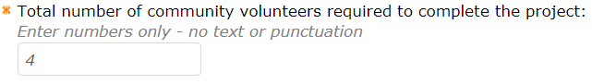
Enter the number of volunteers who will help to complete your project. Volunteers do not have to be Post members. Remember, no paid contractors can be used.
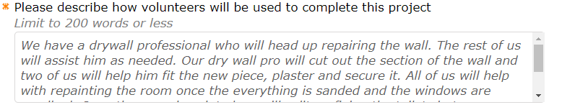
Describe the technical capability of your crew members, how many people will do which jobs, etc. See below for an example. Please note the 200 word limit.
“We have a drywall professional who will head up repairing the wall. The rest of us will assist him as needed. Our dry wall pro will cut out the damaged section of the wall and two of us will help him fit the new sheetrock and finish the wall. All of us will help with repainting the room once everything is sanded and the windows are recalked. Once the room is painted we will split up fixing the toilets into two-man teams. We estimate that we can get everything done between the four of us within a week, but may be done in a couple of days.”

The final question asks about the population group you serve.
Be sure to select “Veterans/Military.”

PROJECT FINANCIALS
Now that you have completed the Statement of Issue and Solution Section, you will arrive at the Project Financials Section. In years passed you could provide an estimated budget to Home Depot. This is no longer the case. You must provide a detailed, line item budget in an Excel file. You can obtain a template for a budget by contacting the Foundation staff using the information at the end of this document. Before any of the answers can be completed, you will need to ascertain the amount the project will cost. There are two ways to do this. You can go into a Home Depot store and get the prices of the items you will need, or use the Home Depot online store. We strongly recommend using the online store, because there is more information available about each item.
This section of the guide will cover each of the three steps needed to finish the Project Financials and later portions of the application. These steps are:
- Obtaining the value of each item using the Home Depot Store.
- Creating a budget using the collected information.
- Using the budget to answers questions in the grant application.

- Creating an Items List
Before you do anything, please consult with the key figures doing the labor for your project and determine everything you’re going to need. Once you have a list of Items you are going to need, proceed to the Home Depot website https://www.homedepot.com.

Once you have accessed the website, type in an item in the search bar as shown below. In most cases, suggestions should pop-up below as you type. For our example project we will need dry wall screws. Notice that it gives the option to click, “in dry wall screws.” If you get an option with “in” before it, select it. This is a dedicated section they have designed for this product type and will give you the most results.
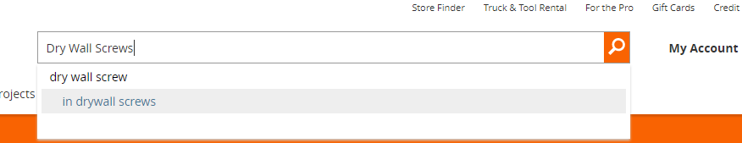
You should now see a page full of search results as shown on the next page.
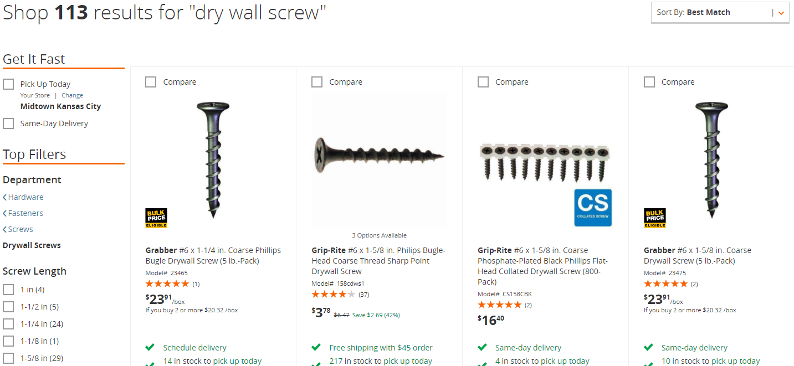

You can use the filter in the top right, shown here reading “Best Match,” or use the selections on the left side to narrow down the results. Determine which item is right for your project and click on its page.
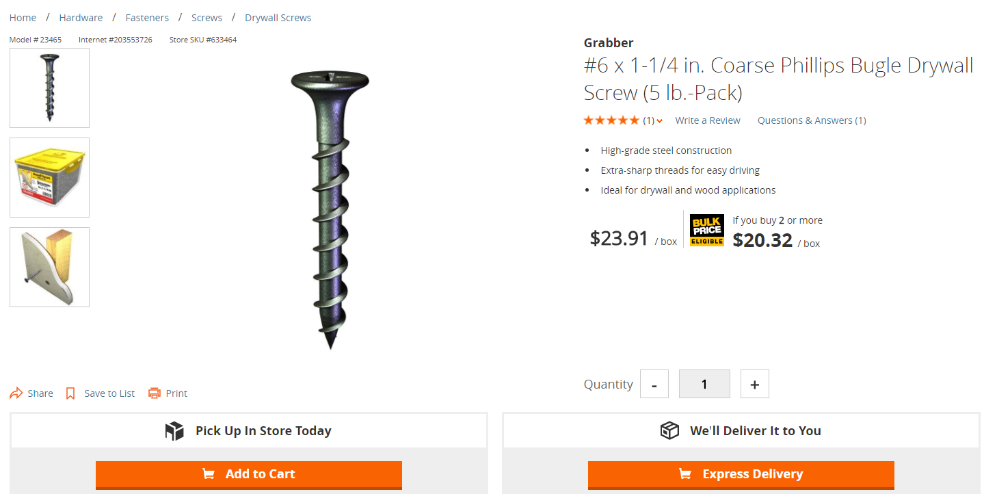

Once you have chosen on an item, click on its page and click “Add to Cart.” You do not need to create a Home Depot account, but you should create your item list in one sitting so as not to lose your work. After clicking “Add to Cart” a pop-up window will appear. Click “Continue Shopping” in the top right of the window as indicated by the red arrow.

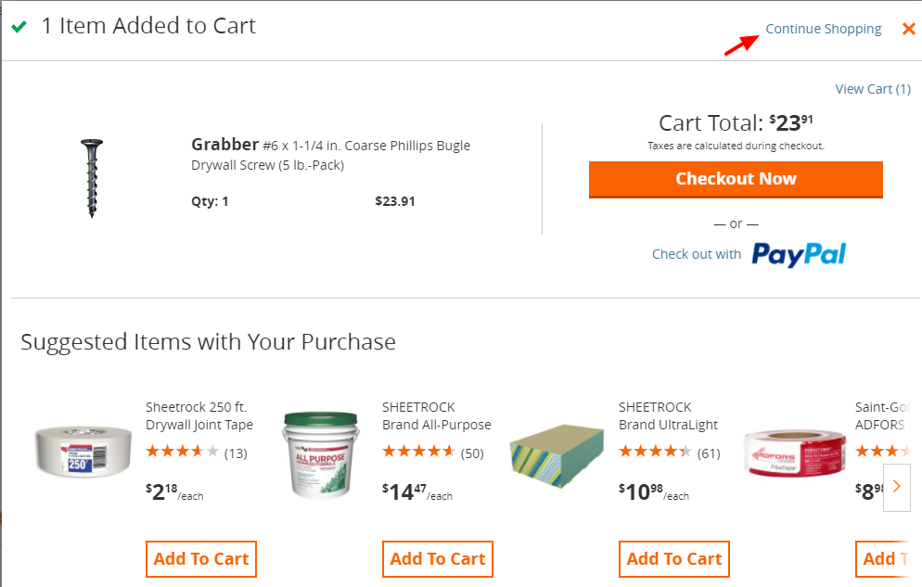

You should now be back to the page you had just come from. If you look at the top right, you should notice that next to cart it says “1 Item.”

Continue this process until everything you need to complete your project is in your cart.

Once everything you need is in the cart click the cart, button on the top right hand side of the screen. For this example, fourteen items are in our cart but only two are shown. It is strongly recommended that you print out this page to make it easier to create a line item budget. Review all of your items and ensure you have everything.

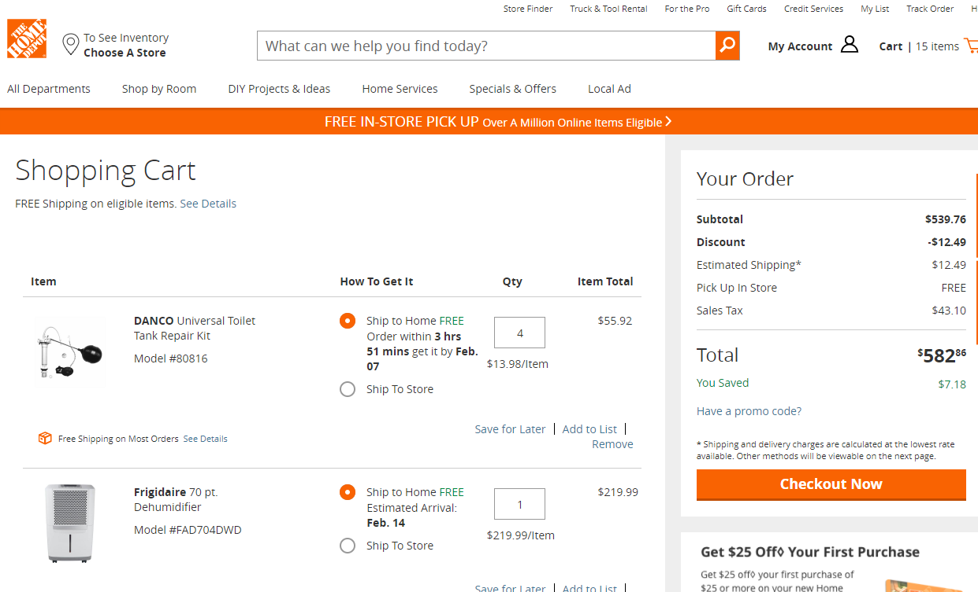

Pay special attention to the quantities of each item and make sure they’re correct. We will use the data under “Your Order,” as well as the data from each item to build our spread sheet as seen on the next page.

- Creating a Budget
Now that you have established which and how many materials you will need, you can proceed to creating your budget. Again, if you are not skilled with Excel, a template can be obtained by contacting the VFW Foundation staff. The budget must be submitted in Excel format. FYI: More than likely, your budget sheet will be quite longer than the example, which you can see on the next page of this guide.

When creating your budget, it is recommended to use the following five column names:

Item Description – Copy this straight from the item page as labeled by Home Depot.

Model Number – Also copy this verbatim, it could be used by Home Depot staff to determine accuracy.

Quantity - Ensure the quantities are correct for each item.

Individual Price - The unit price of each item.

Total Price - This is the item price times the quantity.

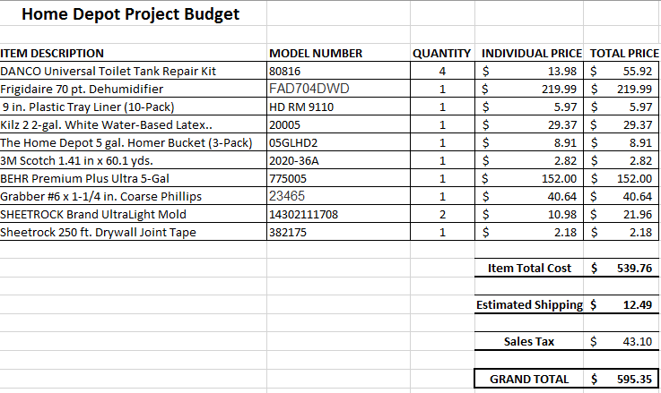
Once you have all of the data entered, add the numbers in the Total Price column to get your Item Total Cost result.
Now that you have the Item Total Cost of the items combined, add a row for Estimated Shipping and one for Sales Tax. Make sure they are doubled spaced and placed directly underneath the Item Total Cost to include the additional costs in your Grand Total. These two figures can be found on the “Your Cost” box on the Cart page as shown on the next page of this guide.

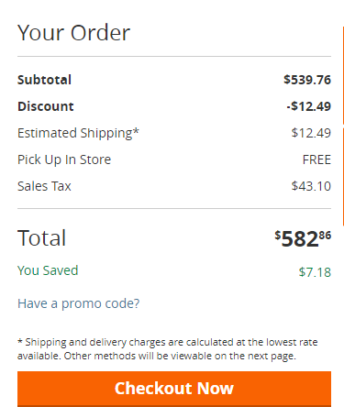

Do not include the “Discount” figure, as this could include current sales that may no longer be valid by the time your grant is reviewed. Add the three items together to determine your Grant Total as shown below.
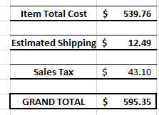
- Now that you have completed the budget, you can answer the questions asked in the PROJECT FINANCIALS SECTION. Be sure to hold onto the budget you created, you will need to attach it to your application before you can submit your grant request.
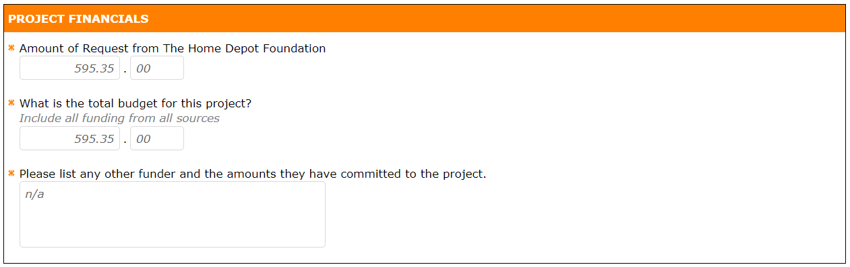

Many of you will have budgets that far exceed the example’s $595.35. Let’s say you are building a ramp for disabled access. The total cost of supplies according to Home Depot is $6,000. This will exceed the $5,000 grant limit by $1,000. The purpose of this section is to find out how you plan to cover the remaining $1,000. No grantmaker wants to give money to a recipient who does not have a plan to fully fund their proposed project. You might say something like this in the third box if your project budget exceeds the limit:

“We held a raffle for a Henry Rifle and raised $500 which we intend to put toward the competition of this project. Furthermore, we raised an additional $400 while distributing Buddy Poppy’s to our community members at a SportClips store next to a highly trafficked grocery store last week. Next week we are holding a Health and Wellness event at a nearby Walgreens. We are confident that between this event and several other planned projects that we can raise an amount far exceeding the remaining $100 needed.”
______________________________________________________________________________

VETERAN INFORMATION
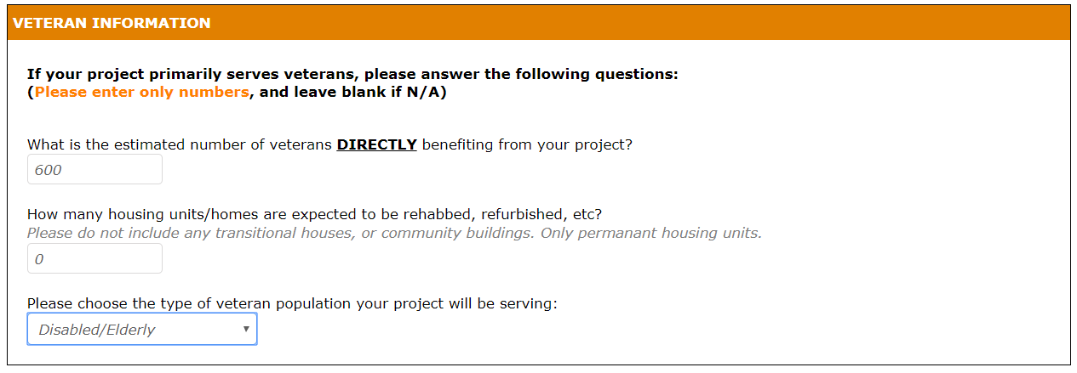

The first question asked in this section is “What is the estimated number of veterans DIRECTLY benefiting from your project?” Start with the number of members your Posts has, then estimate the number served by activities conducted at your Post, and at the totals together.
The answer to the second question should be “0” unless there is living space at your Post and you are specifically asking for funding to renovate or repair that space.
You will now be asked a question about which specific type of veteran population your project will serve. Select the option that best describes who your Post most typically serves. Make sure not to choose “None of the above,” as your project will certainly help at least one of these special population types if not all of them.
Please turn to the next page of this guide for more instructions on completing the STORE INFORMATION section.

STORE INFORMATION
In this section you will provide Home Depot with information about the store you intend to purchase your items from should you be awarded the grant, not necessarily the location closest to your Post building. Proceed to the next page of this guide for instructions on how to obtain the store number.
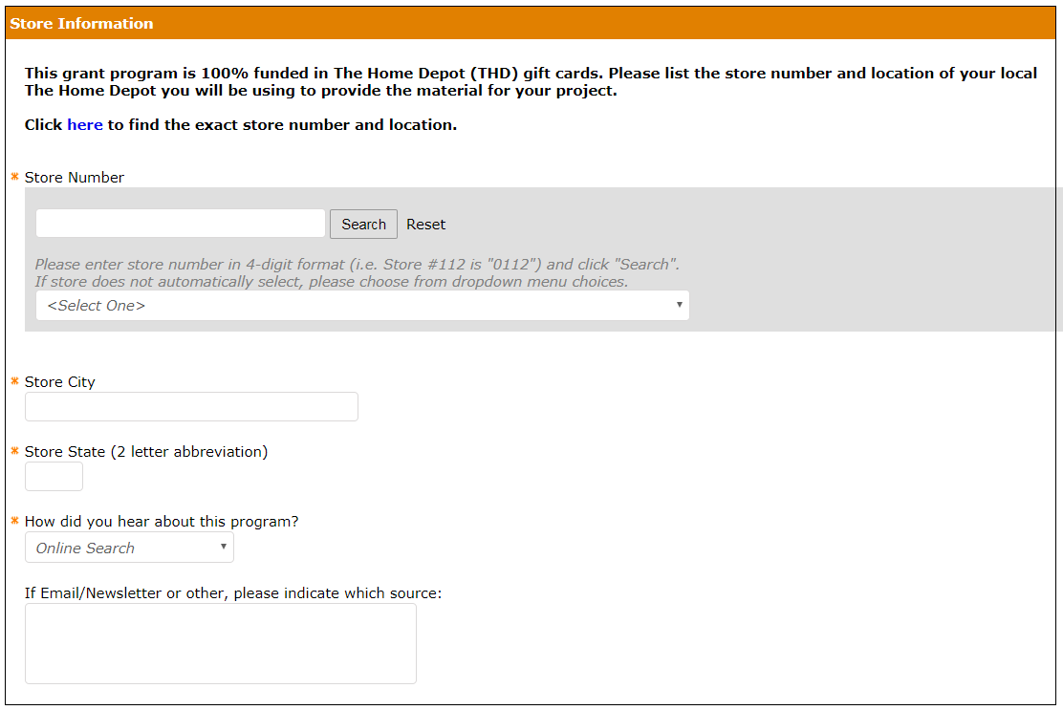
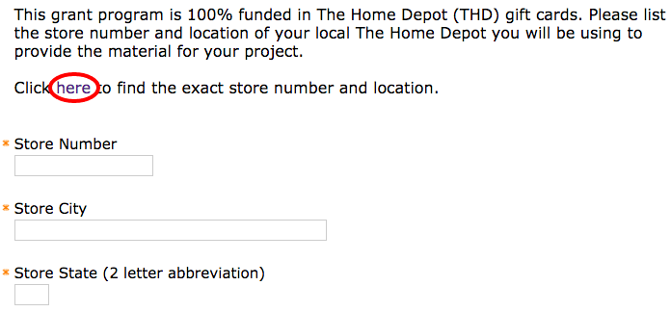
If you click “here” on the application as seen above, the website depicted below will open in a new tab on your browser. The example below shows a map of the Kansas City metropolitan area but it should display the area from your location.
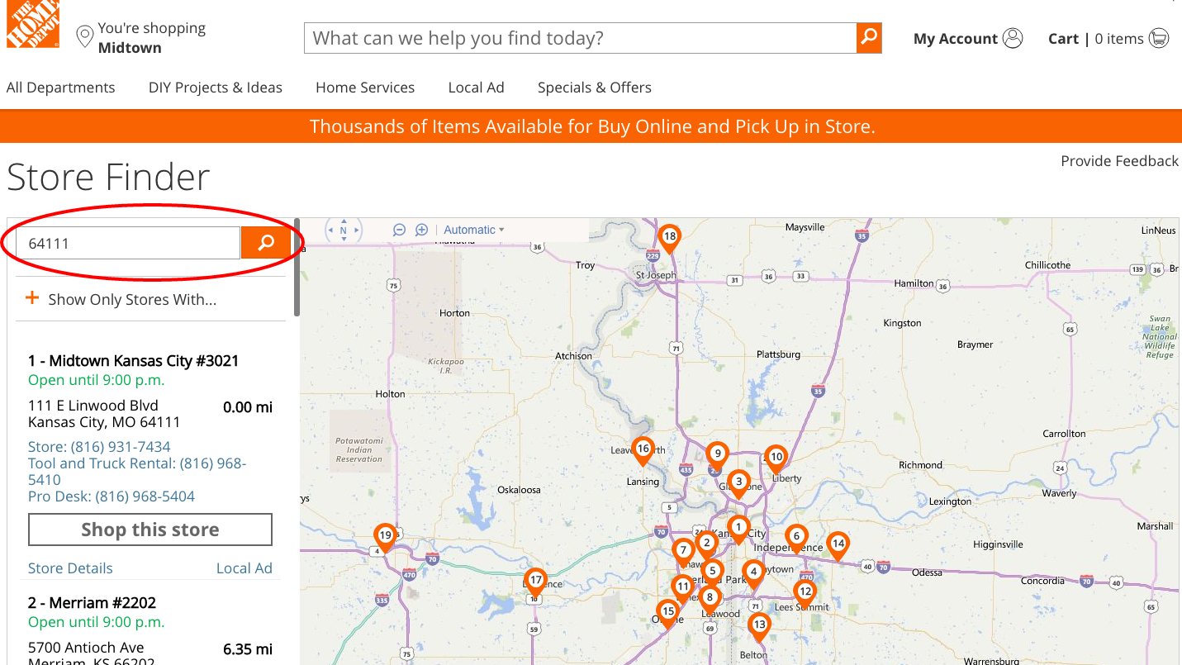

Enter your zip code or city and state in the box circled in red under the “Store Finder” heading and click the magnifying glass icon. Once you have taken this step, a list of stores nearest to the zip code entered will appear under the search field (marked in a red rectangle in the below image). The store number is listed to the right of the store name (indicated by double blue underlining in the example on the next page).
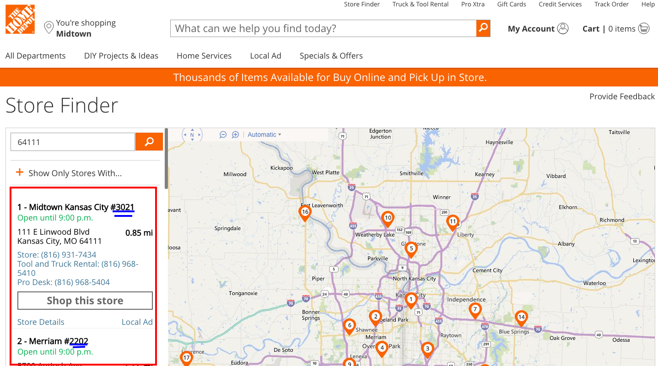
Once you have determined the store number, city and state, enter the information into the appropriate field on the STORE INFORMATION section.
Finally, answer the remaining question about how you heard about this grant.
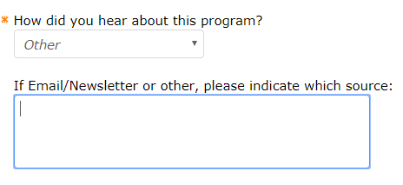
You now should have all of the fields in Part 2 completed.
Ensure that you have not missed anything, and then click the “Next” button at the very bottom of the application page.
After clicking “Next: you will be brought to Part 3 of the application, Grant Terms.
_____________________________________________________________________________
Part 3 – Grant Terms
This page is a set of terms and conditions, which you must agree to before proceeding. You should carefully read through each of them before agreeing. Please turn to the next page of this document to see the terms and what the screen looks like.
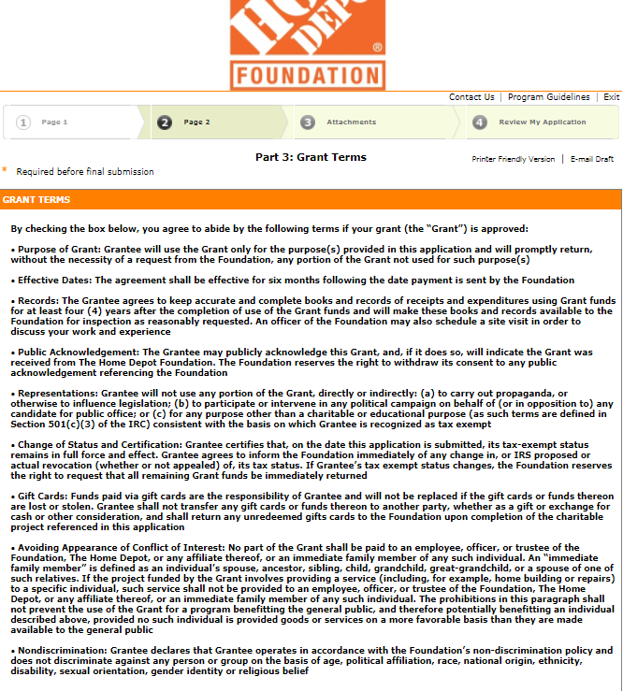

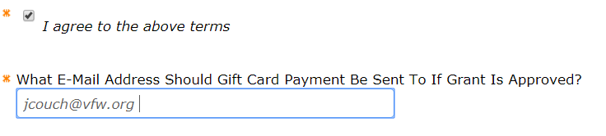
After reading the terms, check the “I agree box to the above terms” box and list the email where you would like the gift cards to be delivered to if you are awarded the grant. Then select “Next” at the bottom to proceed to the attachments page.
______________________________________________________________________________
Attachments
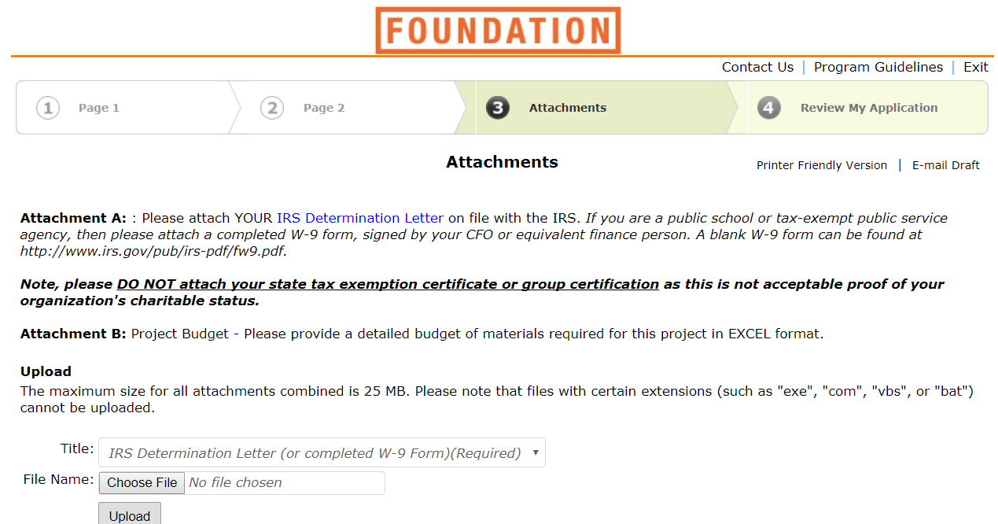
Be sure to upload your Post’s IRS determination letter (Or first page of your previous year’s 990, which Home Depot Foundation also accepts) using the “Choose File” button. Once you click the button, you will receive a prompt allowing you to select the file from your computer. Choose the correct file and hit enter and then click the “Upload” button. Repeat this step, but select “Project Budget” on the “Title” drop down menu to upload your budget.
If you have correctly uploaded the files, the page should look something like this:

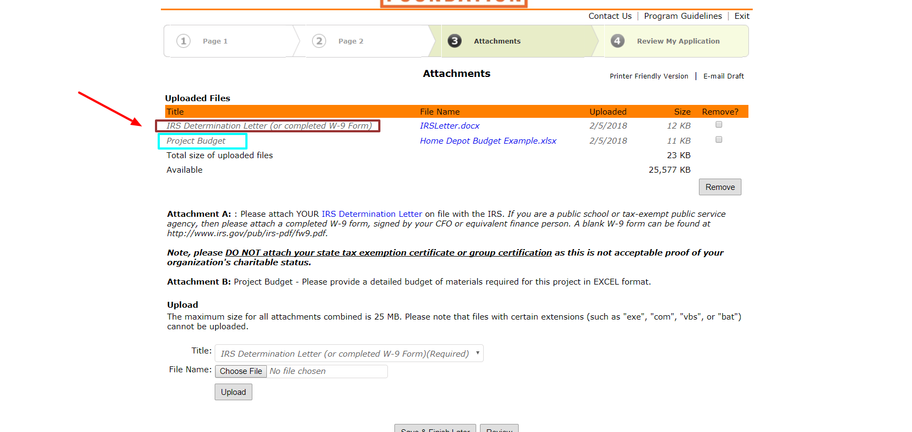
Note the red arrow and colored boxes that have been added. The dark red box is highlighting “IRS Determination Letter,” to its immediate right, the IRS letter we uploaded is listed. This is the same for the light blue box and the budget. Make absolutely sure that you have correctly uploaded the documents before submitting. If you did this incorrectly the first time, you can always check the “Remove” box(es) and click the corresponding button directly underneath them to try again.

Now that your determination letter and budget are uploaded click the Review button at the bottom of the page.
The review page will display all of the information you have uploaded and entered. Carefully review each entry and then click submit at the very bottom of the page. Your request has now been submitted!
Best wishes and good luck with your request!

P.S. Please contact Jason Couch at jcouch@vfw.org or 816-968-1174 if you have any questions at all concerning the application.

